Name | Email | Signature
Prof. Dr. Diana Aga | dianaaga@buffalo.edu
Assoc.Prof.Dr. Aree Choodum | aree.c@phuket.psu.ac.th | 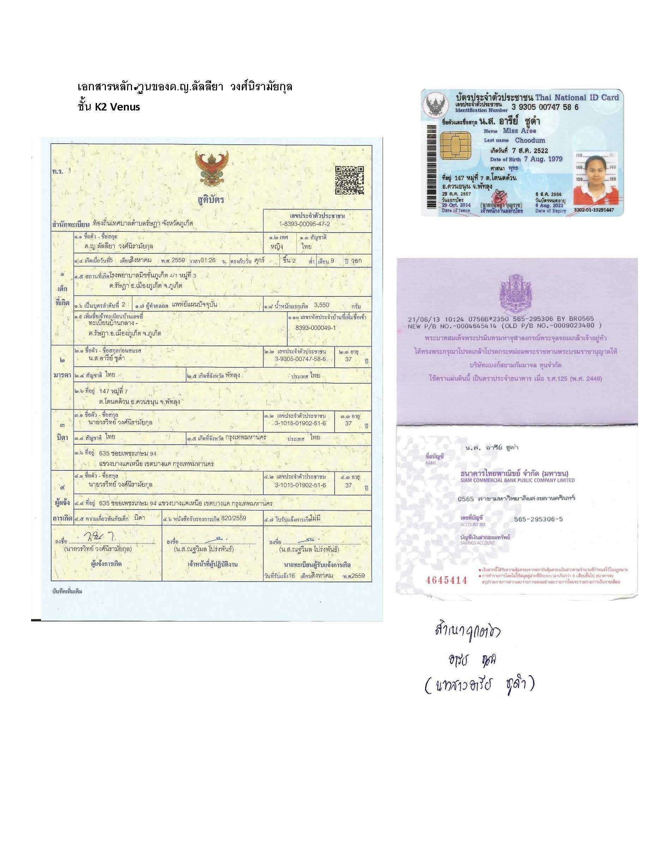
Dr. Tarawee Taweekarn | Tarawee.t@phuket.psu.ac.th | 
Ms. Chanita Boonkanon | chanitabkn@gmail.com | 
Ms. Kharittha Phatthanawiwat | kharittha.p@gmail.com | 
Research discussion in
“Removal of methylene blue using a dried mangosteen peel composited starch cryogel”
8.00-11. 00 am (Thai time) on June 3, 2022

