

**Virtual Visiting Professor Program**

**Islamic Studies International Program**

**Faculty of Islamic Sciences,Prince of Songkhla University:**

**ISSUE**

**What Can We Learn from the Swedish Buytul Almal (The Swedish Model) to Improve the Management of Local Buytul Almal in the Four Southern-most Provinces of Thailand?**

**By**

**Associate Professor Dr. Kamaruddin Abdulsomad**

**Lund University, Sweden**

**Wednesday 23-02-2022**

**Virtual Visiting Professor Program**

**Islamic Studies International Program**

**Faculty of Islamic Sciences,Prince of Songkhla University:**

**ISSUE**

**What Can We Learn from the Swedish Buytul Almal (The Swedish Model) to Improve the Management of Local Buytul Almal in the Four Southern-most Provinces of Thailand?**

**By**

**Associate Professor Dr. Kamaruddin Abdulsomad**

**Lund University, Sweden**

**Wednesday 23-02-2022**

**What Can We Learn from the Swedish Buytul Almal (The Swedish Model) to Improve the Management of Local Buytul Almal in the Four Southern-most Provinces of Thailand?**

**Statement of the Problem:**

1- Many Islamic countries such as Malaysia and (Thailand) has been very successful in managing their Islamic finance for many decades without raising the standard of living of their population.

2- Malaysia and Thailand have been living with increasing poverty levels and low levels of Middle income traps (UN Report)

**Problem**

3. Islamic Economics Theory have not put into fully practices in many Islamic communities.

4. The moral issues of Islamic Economics have been lost.

5. Poverty and Inequality have been widespread in many Islamic communities despite high growth and opportunity.

6. Many local Muslim Institutions have lost their credibility in raising at a higher income level

**Our discussion for this lecture**

1. What is principle teaching, rules of behaviour and institutions in Islam?
2. What is a Swedish Model and how it management can be used to improve our local institutions to fucntion better?

3. Local institutions in the four southernmost provinces

**What Can We Learn from the Swedish Buytul Almal (The Swedish Model) to Improve the Management of Local Buytul Almal in the Four Southern-most Provinces of Thailand?** **Statement of the Problem:**

1- Many Islamic countries such as Malaysia and (Thailand) has been very successful in managing their Islamic finance for many decades without raising the standard of living of their population.

2- Malaysia and Thailand have been living with increasing poverty levels and low levels of Middle income traps (UN Report)

**Principle Teachings, Rules of Behaviour and Institutions in Islam**

* The Unity of Creation and Freedom of Choice
* Human and Economic Development in Islam
* Economic Structure and the Rules of Behaviour in Islam
* The Islamic Vision of Distributive Justice
* Islamic Finance
* Institutions and their Importance in Islam

**1. The Unity of Creation and Freedom of Choice**

1.There are four fundamental concepts in the Islamic system

*Walayahh* = the unconditional, dynamic, active, ever-present Love of the Supreme of His Creation manifested through the act of creation and the provision of suffiecient resources to sustain life.

Humans reciprocate this love by extending their love other humans and to the rest of creation.

The persuit of walayahh is love manifested through knowledge and the upholding of justice.

2. The second is *karamah* = Human dignity.

The Quran considers humans to be the crowning achievement of the creation.

An important facet of this is the freedom that has been gifted to humans – to think, to decide and to choose their path in life, while supporting good and opposing evil.

3. The third is the *meethaq* = the primodial covenant in which all humans are called before their Supreme Creator and asked to testify that they recognize Him as the One and Only Creator and Sustainer of the entire Creation and all other implications flowing from this testimony.

4. The fourth concept is *Khilafah* = agency-trusteeship. Khilafah is the empowerment of humans by their Creator as agent – trustees to extend Walayahh to one another; materially through the resources provided to them by the Creator, and non-materially through unconditional love for their own kind as well as for the rest of creation, which can be best displayed by the pursuit of unity and justice.

* A number of verses of the Quran affirm the unity of mankind [1:4; 13:49; 28: 31]
* These verses plus those dealing with the availability of resources as well as human endownments are the foundation of the legislative framework of rules (Institutions) for the socio-economic-political behaviour of humans.

**2. Human and Economic Development in Islam**

* The concept of development in Islam has three dimensions:

1. Individual self-development called *rushd*. The first specifies a dynamic process in the growth of the individual toward perfection.
2. The physical development of the earth called i*sti mar*. The second specifies the utilization of natural resources to develop the earth to provide for the material needs of this individual and humanity.
3. The development of the human collectively, which includes both. The third concept refers to the belief that the Supreme Creator has provided the ways and the means to facilitate the achievement of all three dimensions of development.
4. Scarcity is not the root cause of excessive inequality and distributional injustice, instead it is selfishness, the misuse of resources and human greed that cause scarcity, poverty, misery and destitution.
5. Self- development is necessary to transcend selfishness.
6. According to Islam, there are sufficient Resources if individuals share. The notion of sharing is central in Islam.

When it comes to the development of the human collectivity, the Quran recognizes legitimate authorities, namely selected rulers

governments.

The important point here is that those in positions of authority must be rule-compliant if they are to oversee the implementation of the prescribed rule.

**3. Economic Structure and the Rules of Behaviour in Islam**

* During his ten years in Medina, the Prophet developed numerous rules to guide economic and social behaviour: rules of governance, accountability and transparency, rules regarding property regarding property ownership and protection, rules regarding the formation and the structure of the market; rules concerning the role of the state in overseeing the market; rules of behaviour by market participants; rule regarding distribution and redistribution; rules related to education, technological progress and society’s infrastructure and rules regarding sources of government income and its expenditures.
* The central exis of design and operation of these rules is justice.

**4. The Islamic Vision of Distributive Justice**

* The concept of distríbutive justice the just division of the economic pie (production and wealth) among the members of society that includes owners of capital, workers, those that cannot provide for themselves and the animal species since many centuries is far from settled. Some see a role of for governments in its enforcement others do not.

The Quran does not afford a separate or stand –alone theory of justice. Instead, the Quran indicate that compliance with rules of behaviour handed down in the Quran and interpreted by the Prophet assures the emergence of justice as a natural outcome of the practice of a rule compliant society.

Justice and a just political, social and economic system is thus an essential outcome of the Islamic system if Muslims comply with Divine rules.

Simply said, a society will be just in Islam if the rulers and the people are rule-compliant. Islam has two simple propositions for a just society (1) place things in their rightful position and (2) give everyone rightful due. The first can be merged into the second. The rightful place and right due are guaranteed by compliance with the rule.

Given the rules governing property rights, work, production, exchange, markets, distribution and redistribution, it is reasonable to conclude that in a rule-complying and Allah-conscious society, absolute poverty could not exist.

The Prophet said that poverty is near disbelief and that poverty is worse than murder.

It is almost axiomatic that in any society in which there is poverty, Islam rules are not being observed. Thus rulers who live in opulence are prima facie not rule compliant, but those who do so while others live in poverty are also unjust and illegitimate.

**5. Islamic Finance**

* The central proposition is risk sharing, which allows both parties to reduce the risk of income of volatility and to allow consumption smoothing, a major outcome of risk sharing.
* More recently, a number of economists are again questioning the stability of conventional finance.

**6. Institutions and their Importance in Islam**

1. To lower transaction costs (North 1990) for high performing economies.
2. Transaction costs are an impediment to economic and social progress and prosperity.
3. They arise because getting access to information is costly and held asymmetrically by parties to an exchange.
4. It can be argued that tghe collectivity of institutions provides society with the social capability to establish a stable order by reducing uncertainties or ambiguities members of society face.

Islam requires institutions that monitor and enforce distribution and redistribution, that eradicate poverty and provided for those who cannot provide for themselves and who are still in need after individuals have done what is required of them, and insure a level playing field with equal access to high quality education and healthcare.

**we must emphasize the capstone rule in Islam:**

1. The rule commanding the good and forbidding evil
2. Applicable to individuals and society
3. Assures that leaders are selected by the community and are answerable for the actions
4. Leaders acquire legitimacy by being more rule-compliant than members of the community.
5. leaders must be confronted if they do not uphold Divine Rules and enforce them.
6. Income inequality absolute and relative poverty is evidence of rule-violation and governance failure.

**Concluding Comments on the Islamic System**

* Allah could have created a world of total perfection inhabited by ”perfect” humans that had no free will.
* If Allah has done so, human dignity would have been empty of any meaning.
* Allah gave human freedom.
* Islam is founded on freedom, equlity and justice.
* Thus the concept of justice in Islam is founded on freedom and equlity of humankind.
* Allah gave humans bountiful resources that, if managed well and shared , could satisfy all human needs.
* The Islamic economic system is a market based which is different from some capitalist economic theory.
* Islam does not have a separate theory of justice.
* Muslim countries need drastic institutional Reforms – social, economic and political – to realize their potential and reverse the centuries of missed opportunities.

**Long term Structural Transformation of the Economy**

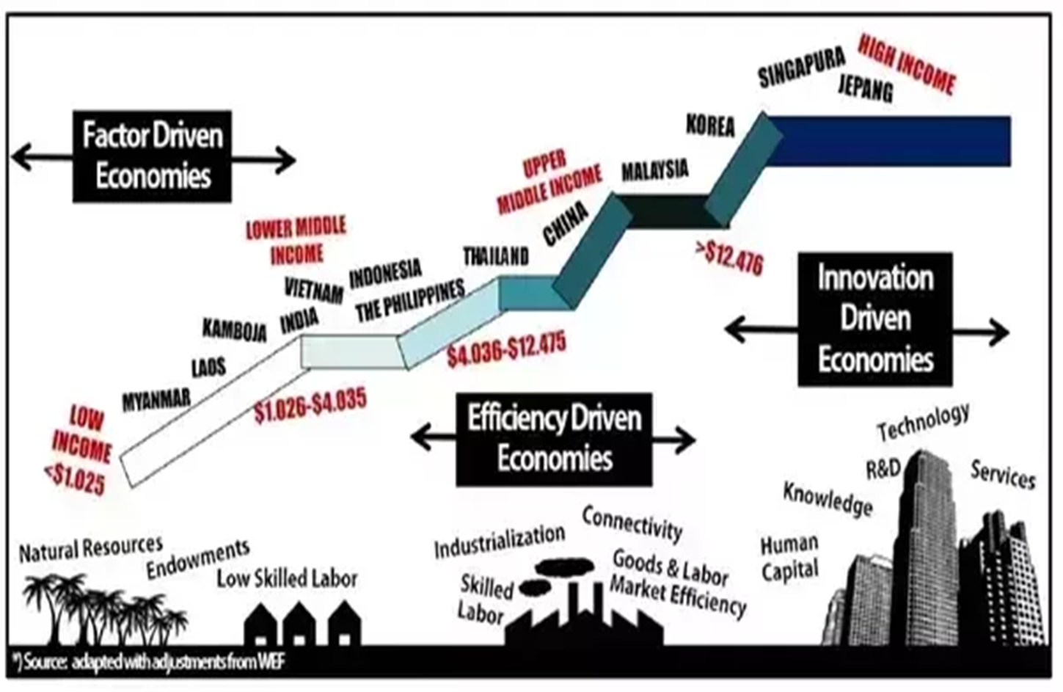

**The Technological Ladder Hypothesis**

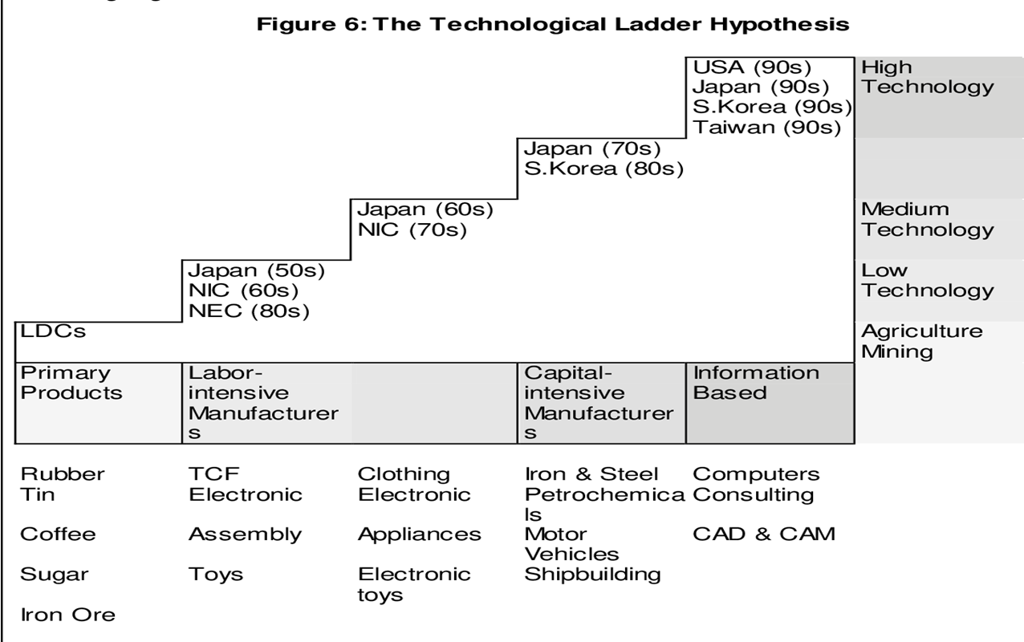

**Techno-Economic Paradigm by Perez & Freeman**

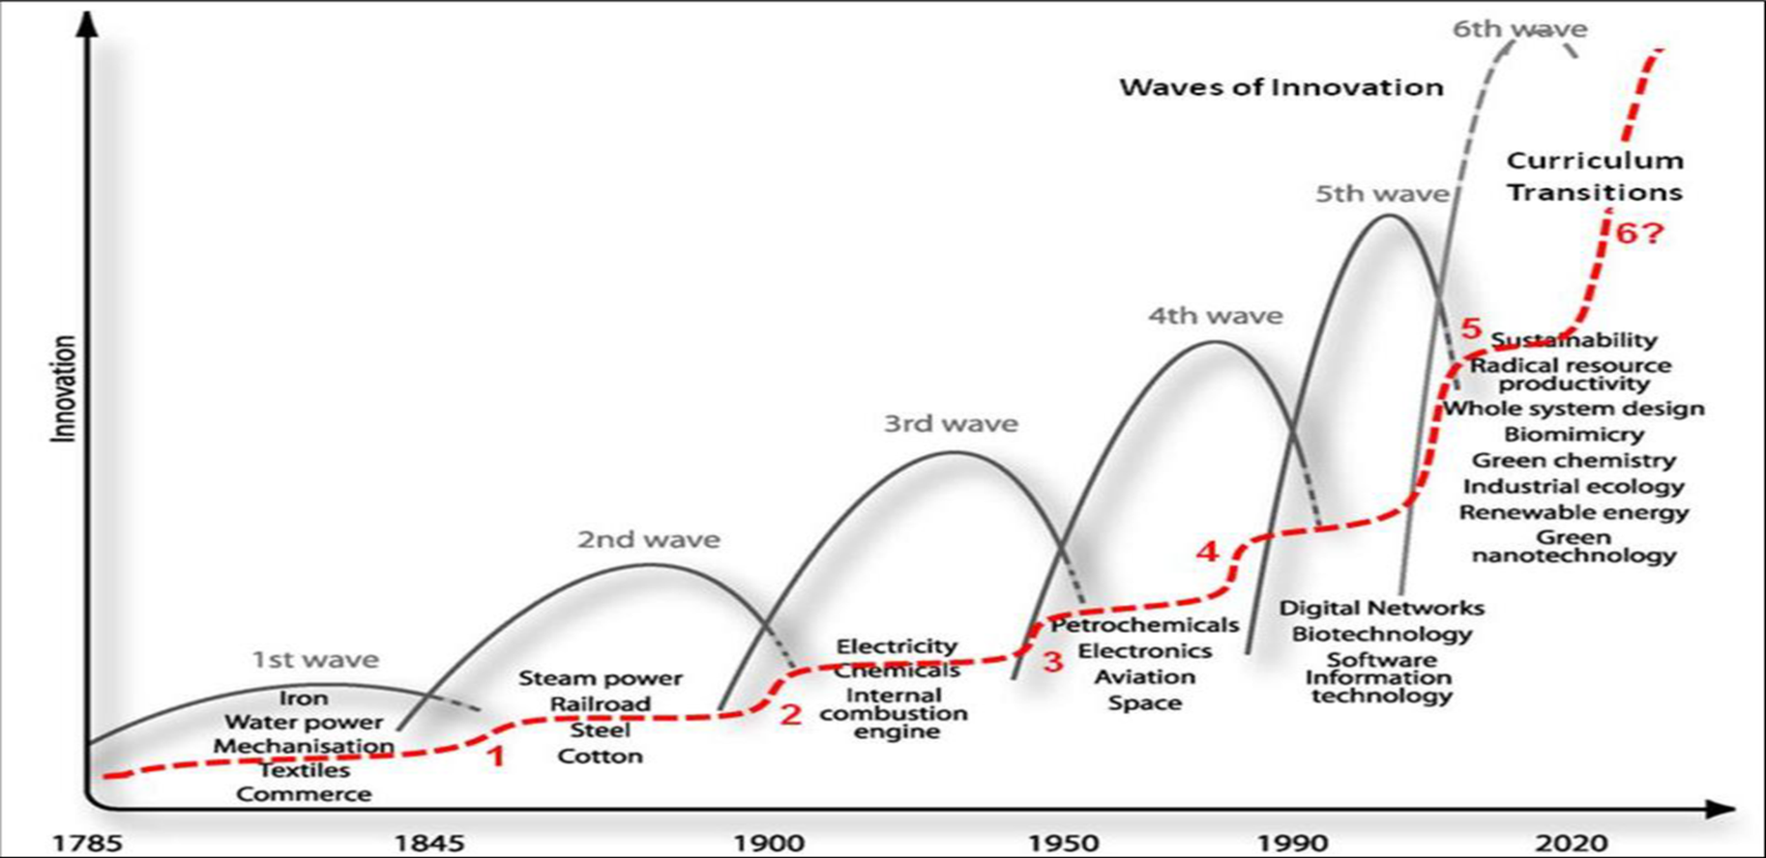

**1. The Swedish Model**

Sweden with 10 million population is a prosperous country whose wealth is evently distributed.

The Swedish model is a strategy for inclusive growth.

The Swedish Model can be said to consist of three fundamental pillars: a labour market, that facilitate adjustment to change, a universal welfare policy and an economic policy that promotes openness and stabilty.

**The Swedish Model**

Prerequisites

Sound public finances

Trust, legitimacy

High employment

Strong and equal social partners

**2. The main objectives of the Swedish Model**

**2.1 Prosperity, equity and gender equality**

1. The Swedish Model is to ensure that prosperity increases and is eqitably distributed among citizens.

2. High and rising prosperity is dependent upon a dynamic business sector that contributes to high productivity growth and employment.

3. The equity goal is based on the fundamental belief in the equal value of all human beings and their equal rights to independent and autonomous live

4. Unemployment is the most common cause of economic disadvantage and lack of work also entails exclusion from many social contexts.

5. The effort to achieve equitable distribution of income thus begins in the labour market, where the education policy and the active labour market policy, along with coordinated wage formation, are intended to create the conditions for high and equally distributed real wages.

This requires policy to be designed so that everyone is provided good opportunities for education and work, regardless of social background. The redistribution policy has impact through taxation and transfer systems that further equalise disposible incomes.

6. Need-based provision of publicly financed servises, such as schools, elderly care and healthcare also contributes to more equitable distribution of total resouces.

**2.2 Autonomy and independence**

One of the goals of the Swedish model is to safeguard citizens autonomy and independence and prevent power imbalance (employees and employers)

The Swedish model minimises the immediate ties of dependency on family, neighbors, employers and civil society organizations.

**3. The relationship between Efficiency and Equity**

* The large public sector debate in Economics
* Okun (1975) the big trade-off
* Andersen SOU (2015) moral hazards in policy design. A good balance between rights conditional upon duties
* Lindbeck (2008) and Ljunge (2011), time and system designed
* Andersen and Maibom (2016) economic performance and resources are used effieciently if institutions are well-designed and the state of technolological progress. Well designed policy and good institutions.
* Sweden, Denmark, Norway and Finland have managed well in terms of efficiency and equality.

**3.1 The relationship between welfare policy and the long-term GDP level**

* Empirical research has found evidence of a correlation between the type of expenditure and tax and economic performance.
* Productive expenditures are associated with better economic performance if financed by the least distortionary modes of taxation.
* Productive expenditures are such that have a direct impact on employment and income (spending on education and childcare).

**3.2 Welfare ” from the cradle to the grave”**

* Another central aspect of the Swedish model is that the publicly provided welfare services and the social security systems cover an individual’s entire life course from the cradel to the grave.
* Children and youths are the beneficiarise of children and education, older people of long-term care services and pensions, while the working-age population are contributors through income taxes.
* All age groups are beneficiaries of healthcare and transfers, but to various extents.
* Economies with stronger social contracts across generations have relatively larger public sectors but because the public sector partially overcomes market failures and results in higher investments in welfare in general and education in particular, it also generates higher prosperity (output).

**4. The model’s pillars and prerequisites**

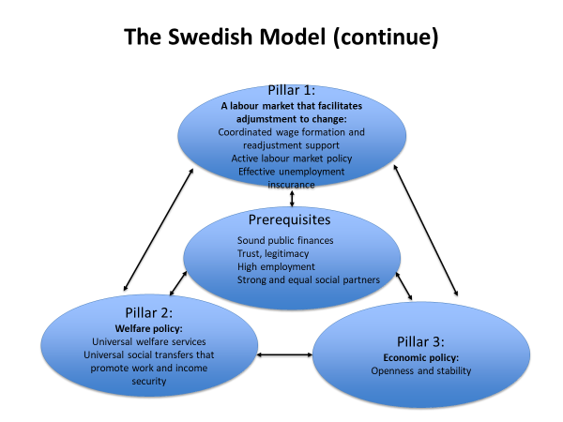

**3. Local Institutions**

**How Buytul Al-Mal has been practiced at local institution level?**

* Majlis Agama Islam at provincial level
* Masjid
* Or Bor Tor
* Thesaban

**I.Islamicity Indices and their Elements Economic Islamicity Index**

**1. Economic Opportunity and Economic Freedom**

1.1 Business Environment

1.2 Economic Regulation Indicator

1.3 Ease of Doing Business Indicator

1.4 Economic Freedom Indicator

1.5 Business and Market Freedom Indicator

**2. Job creation and Equal Access to Employment**

2.1 Equal Employment and Job Creation

2.2 Labour Freedom

**3. Property Rights and Sanctity of Contracts**

3.1 Property and Contract Rights

**4. Provisions to Eradicate Poverty, Provision of Aid and Welfare**

4.1 Poverty Effectiveness Indicator

4.2 World Given index

4.2.1 Helping a stranger

4.2.2 Donating money

4.2.3 Volunteering time

4.3 Social Welfare

**5. Supportive Financial System**

5.1 Investment Freedom

5.2 Financial Freedom

5.3 Moneytary Freedom

5.4 Financial Market Risk Indicator

**6. Adherence in Islamic Finance**

6.1 Absence of Interest indicator

6.1.1 Central Bank discount rate

6.1.2 Commercial Bank prime lending rate

**7. Economic Prosperity**

7.1 Economic Prosperity

7.2 Price Stability

7.3 GDP per capita

7.4 GDP Per Capita Average Growth Rate

**8. Economic Justice**

8.1 Income Distribution

**II. Legal and Governance Islamicity Index**

**9. Legal Integrity**

**9.1 Legal and Judicial Integrity Indicator**

9.1.1 Judicial independence

9.1.2 Impartial courts

9.1.3 Integrity of the legal system

9.1.4 Protection of property rights

9.1.5 Legal enforcement of contracts

9.1.6 Regulatory restrictions on the sale of real property

9.1.7 Business cost of crime

**9.2 Military Interference Indicator**

9.2.1 Military interference in the rule of law and the political process index.

9.2.2 Reliability of police

**10 Prevention of Corruption**

10.1 Transparency International Indicator

10.2 Freedom from Corruption Indicator

**11. Safety and Security Index**

11.1 Safety and Security Index

**12. The Management Index**

12.1 Government Management

12.1.1 Level of difficulty

12.1.2 Management performance

12.1.3 Steering capability

12.1.4 Resource efficiency

12.1.5 Consensus building

12.1.6 International cooperation

12.2 Management of Depletable and other Natural Resources

12.2.1 Protection of animal rights

12.2.2 Environmental health

12.2.3 Air quality

12.2.4 Water resources

12.2.5 Productive natural resources

12.2.6 Biodiversity and habitat

12.2.7 Sustainable energy

**13. Government Governance**

13.1 Voice and Accountability Indicator

13.2 Political Stability and Absence of Violence Indicator

13.3 Government Effectiveness Indicator

13.4 Regulatory Quality Indicator

13.5 Rule of Law indicator

13.6 Control of Corruption Indicator

**III. Human and Political Rights Islamicity Index**

**14. Human Development**

14.1 Human development index

**15. Social Capital**

15.1 Social Capital Indicator

**16. Personal Freedom**

16.1 Personal Freedom Index

**17. Civil and Political Rights**

17.1 Civil Liberty Indicator

17.2 Political Rights indicator

**18. Women’s Rights**

18.1 Gender Inequality

18.2 Proportion of Seats Held by Women in the National Parliament

18.3 Ratio of women to men

**19. Access to Education**

19.1 Education Indicator

19.2 Education Prosperity

19.3 Education Equality Indicator

19.4 Education Effectiveness

**20. Access to Healthcare**

20.1 Life Exoectancy at Birth

20.1 Health Quality

20.2 Health prosperity

20.4 Mortality Rate

**21. Democracy**

21.1 Global Democracy index

**IV. International Relations Islamicity Index**

**22. Globalisation index**

22.1 Economic Globalization Indicator

22.1.1 Globalization Index

22.1.2 Restrictions

22.2 Social Glabalization Indicator

22.2.1 Personal Contact

22.2.3 Cultural proximity

22.2.4 Freedom of foreigner to visit

22.3 Political Globalization Indicator

**23. Military Wars**

23.1 Militarization Index