PSU OPEN MOBILITY Knowledge and Innovation through International Collaboration (Virtual Exchange 2021)
Topic:Circular Economy and Sustainable Development
By: Prof. Dr. Raphael Wasserbaur fromUniversity of Graz, Austria
Date: December8th, 2021 (1:00-5:00 p.m., GMT+7)
Place: Faculty of Environmental Management, Prince of Songkla University, Thailand

No. | Student ID (PSU) | Name - Surname | Signature | E-mail
1 |  | WarangkanaJutidamrongphan | 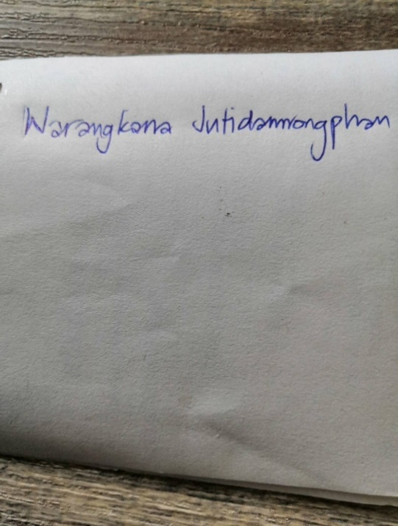 | Warangkana.j@psu.ac.th
2 | 6410930008 | Samnang Tim | 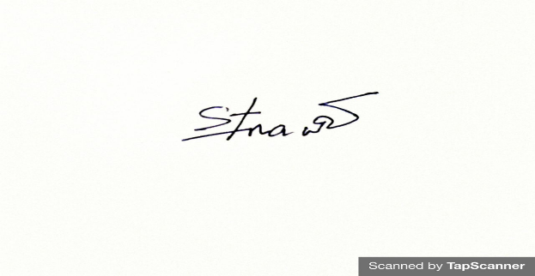 | samnangpp@gmail.com
3 |  | Dharma Raj Pathak | 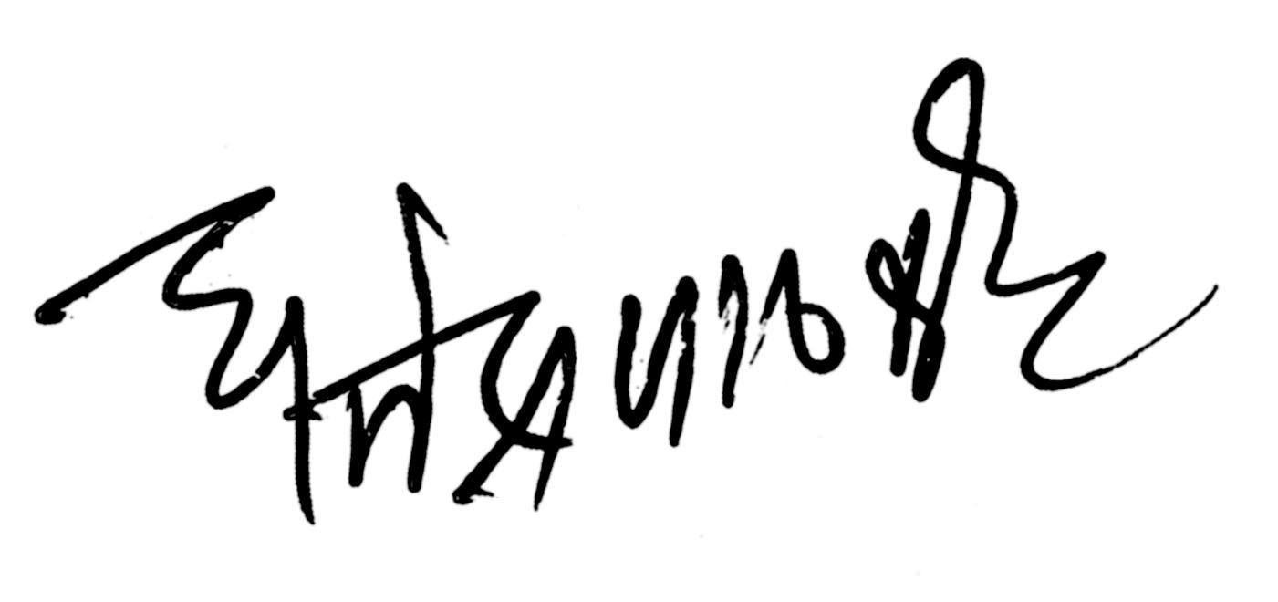 | Drpathak97@gmail.com
4 | 6310930060 | MD. Shahariar Chowdhury |  | Mdshahariar.c@psu.ac.th
5 |  | Wichitra Leelasuphakul | 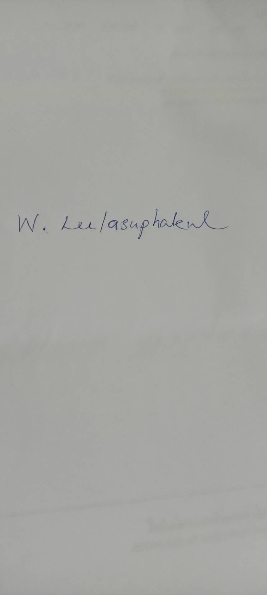 | Wichitra.l@gmail.com
6 |  | Brian Gada
7 |  | Chhabilal Kandel
8 |  | Jagdish Nepal
9 | 6310930016 | Keshav Raj Panthee | Keshav | krpanthee@gmail.com
10 |  | Kutamahufa
11 |  | Rajeev R Pandey
12 |  | Suman Budhathoki
13 |  | Zivanai Kandenga
14
15
16
17
18
19
20

