PSU OPEN MOBILITY Knowledge and Innovation through International Collaboration (Virtual Exchange 2021)
Topic:Research Methodology: Data management and Data Analysis
By: Asst. Prof. Dr. Jacky Cheah Jun Hwa fromUniversity Putra Malaysia (UPM), Malaysia
Date: December20th, 2021 (1:00-4:00 p.m., GMT+7)
Place: Faculty of Environmental Management, Prince of Songkla University, Thailand

No. | Student ID (PSU) | Name - Surname | Signature | E-mail
1 |  | WarangkanaJutidamrongphan | 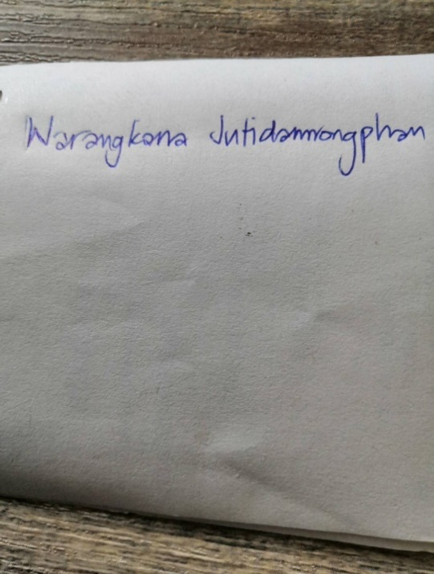 | Warangkana.j@psu.ac.th
2 | 6410930008 | Samnang Tim |  | samnangpp@gmail.com
3 |  | Kuaanan Techato |  | uhugua@hotmail.com
4 | 6310930060 | MD. Shahariar Chowdhury |  | Mdshahariar.c@psu.ac.th
5 |  | Zivanai Kandenga |  | Zkandenga@gmail.com
6 |  | Li Le Jane |  | Gs59449@student.upm.edu.my
7 |  | Mangaiso BM |  | brightmangaiso@gmail.com
8 |  | May Phue Wai |  | Phue.wai.may@gsc.itc.edu.kh
9 |  | Rithy Kan |  | Kan.rithy@itc.edu.kh
10 |  | Ly Luka |  | Ly.luka@yahoo.com
11 |  | Laty DPDM |  | Latyma96@gmail.com
12 |  | Meas Mardi |  | measmardi@yahoo.fr
13 |  | Mony Youk |  | monyyouk@gmail.com
14 | 6310930016 | Keshav Raj Panthee | Keshav | krpanthee@gmail.com
15 |  | Dilli Ram Sedai
16 |  | Eangheng
17 |  | Gao Ziyi
18 |  | Wang Siqi
19 |  | Matsheza Trust
20 | 6410930164 | Sanjesh Stha

