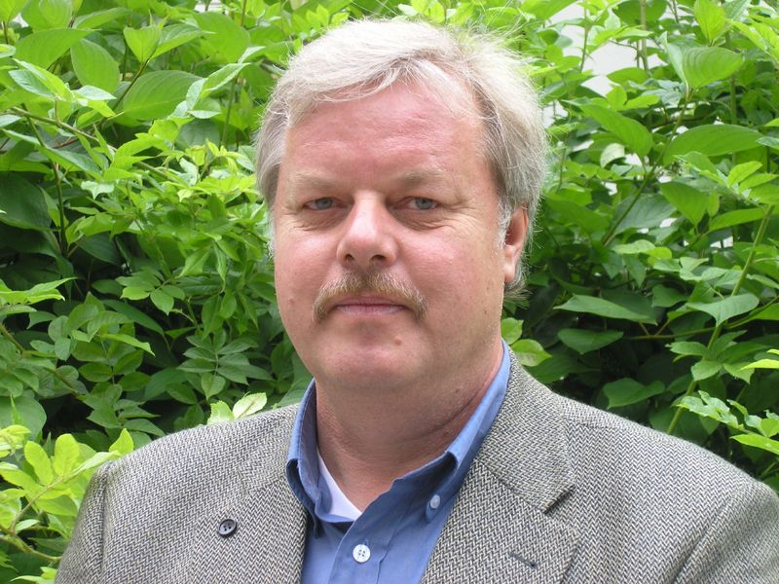

Professor (em) Dr. Rüdiger Korff,
Chair for Southeast Asian Studies (Mainland)

Faculty of Philosophy, University of Passau
Born 1. November 1954 in Bad Oeynhausen, Germany, married, two children
Education:
1984 Ph.D. from the Faculty of Sociology, University of Bielefeld
1990 Habilitation at the Faculty of Sociology, University of Bielefeld
Academic work:
1985 - 1987 Lecturer for Sociology at the Faculty of Political Science, Chulalongkorn University, Bangkok
1987 - 1991 Lecturer and Reader for Anthropology, Faculty of Sociology, University of Bielefeld
1998 to 2000 Professor for Development Sciences, National University of Malaysia (UKM)
2000 to 2004 Professor for Sociology of developing countries, University of Hohenheim
2004 to 2020 Chair for Southeast-Asian Studies, University of Passau
Since 2020 retired
Selected Publications:
Evers, H.D., Korff, R., 2000: Southeast Asian Urbanism. The Power and Meaning of Social Space, Hamburg, London, Singapore, New York: Lit, ISEAS, St. Martins (2. edition: 2003
Helbardt, S., Hellmann-Rajanayagam, D., Korff, R., 2012: Religionization of Politics in Sri Lanka, Thailand and Myanmar, in: Politics, Religion & Ideology, Vol.
Helbardt, S., Hellmann-Rajanayagam, D., Korff, R., 2012: Isomorphism and Decoupling: Processes of external and internal legitimation in Southeast Asia, Sociologus Vol. 62:2
Helbardt, S., Hellmann-Rajanayagam, D., Korff, R, 2010: War’s Dark Glamour: Ethics of Research in War and Conflict Zones, Cambridge Review of International Affairs Volume 23, Issue 2, 249 – 369

Korff, Rüdiger 2021: Between Nation and Global Society: The Role of Metropolis in Southeast Asia in FEEM
Korff, Rüdiger, 2020: Urban Governance, in "Equilibri, Rivista per lo sviluppo sostenibile" speciale, pp. 91-101,

