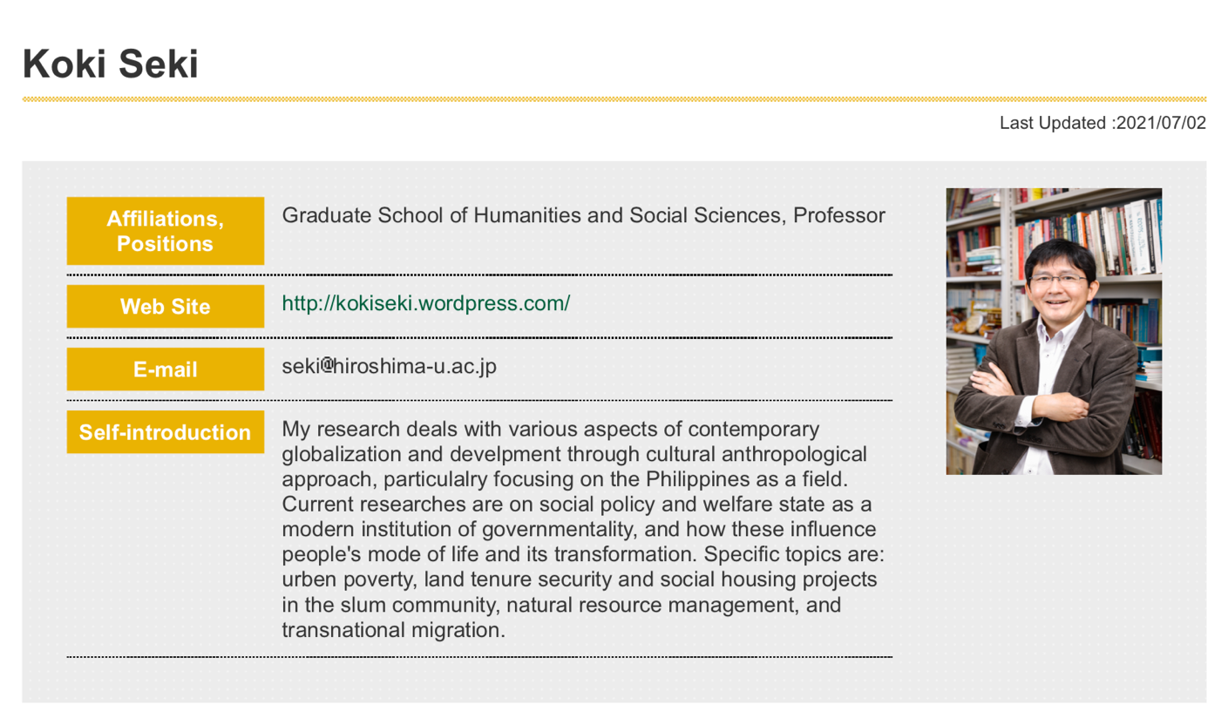

Educational Activity
【Bachelor Degree Program】School of Integrated Arts and Sciences : Department of Integrated Global Studies 【Master's Program】Graduate School of Humanities and Social Sciences : Division of Humanities and Social Sciences
: International Peace and Co-existence Program
【Master's Program】Graduate School of Humanities and Social Sciences : Division of Humanities and Social Sciences : Integrated Arts and Human Sciences Program
【Doctoral Program】Graduate School of Humanities and Social Sciences : Division of Humanities and Social Sciences : International Peace and Co-existence Program
【Doctoral Program】Graduate School of Humanities and Social Sciences : Division of Humanities and Social Sciences : Integrated Arts and Human Sciences Program

Research Fields
Humanities;Cultural anthropology;Cultural anthropology Humanities;Philosophy;Area studies

Research Keywords
Anthropology of Social Policy and Development
Anthropology of Civil Society and Citizenship
Ethnography of Welfare and Security
Risk, uncertainty, and precarity
Post-neoliberalism and "the Social" Globalization and Migration
Governmentality and Subjectivity The Philippines

Affiliated Academic Societies
Japanese Society for Cultural Anthropology
Japanese Society for Southeast Asian Studies
The American Anthropological Association
Japan Society for International Development Related URL

Course in Charge
- 2021, Liberal Arts Education Program1, 3Term, Contemporary World Issues I
- 2021, Liberal Arts Education Program1, 1Term, Introduction to International cooperation
- 2021, Graduate Education (Master's Program) , 4Term, Japanese Experience of Human Development-Culture, Education, and Health
- 2021, Graduate Education (Master's Program) , 4Term, Japanese Experience of Human Development-Culture, Education, and Health[On-Demand]
- 2021, Undergraduate Education, 2Term, Tourism Studies
- 2021, Undergraduate Education, Year, Graduation Thesis
- 2021, Undergraduate Education, 1Term, Anthropology of Globalization I
- 2021, Undergraduate Education, 2Term, Anthropology of Globalization II
- 2021, Graduate Education (Master's Program) , 2Term, Humanities and Social Sciences and Society
- 2021, Graduate Education (Master's Program) , 1Term, Peace and Co-existence A
- 2021, Graduate Education (Master's Program) , 2Term, Basic Cultural Anthropology II
- 2021, Graduate Education (Master's Program) , 4Term, Contemporary Anthropology II
- 2021, Graduate Education (Master's Program) , Academic Year, Special Study
- 2021, Graduate Education (Master's Program) , Academic Year, Special Study(2021 Oct. Master Students)
- 2021, Graduate Education (Doctoral Program) , Academic Year, Special Study (2021 October Doctoral Course)
- 2021, Graduate Education (Master's Program) , 3Term, Social Anthropology
- 2021, Graduate Education (Master's Program) , 2Term, Reading Ethnography
- 2021, Graduate Education (Master's Program) , First Semester, Seminar on Cultural Dynamics
- 2021, Graduate Education (Doctoral Program) , First Semester, Seminar on Cultural Dynamics II
- 2021, Graduate Education (Doctoral Program) , First Semester, Seminar on Cultural Dynamics I
- 2021, Graduate Education (Master's Program) , Second Semester, Seminar on Cultural Dynamics
- 2021, Graduate Education (Doctoral Program) , Second Semester, Seminar on Cultural Dynamics II
- 2021, Graduate Education (Doctoral Program) , Second Semester, Seminar on Cultural Dynamics I

Academic Papers
- ★, Seki, K. Capitalizing on Desire: Reconfiguring "the Social' and the Government of Poverty in the Philippines, DEVELOPMENT AND CHANGE, 46(6): 1253-1276, 2015Link to Paper Search Results by DOI
- Seki, K. Identity of Migrant Children and Representation of "Family": The Case of Filipino 1.5-Generation Immigrants in the United States, Japanese Journal of Cultural Anthropology, 78(3):367-398, 2013., Japanese Journal of Cultural Anthropology
- ★, Difference and Alliance in Transnational Social Fields: The Pendular Identity of the Filipino Middle Class, Philippine Studies, 60(2), 187-222, 20120101
- ★, Green Neoliberalism, Agency, and Cummunity: A Case of Coastal Resource Management in the Philippines, Cultural Anthropology, Vol.73(4): 477-498, 2009, 20090301
- Green Neoliberalism, Ecogovernmentality, and Emergent Community: A Case of Coastal Resource Management in Palawan, the Philippines, Philippine Studies, 57(4), 901-36, 20090101
- Subject, Agency, and Identity in the Lowland Philippines: Focusing on the Concept of "Dungan" as a Folk Notion of Power, SHI'EN, 64(2), 13-38, 20030401
- Anthropological Study on the Development of Livelihood Strategy and Identity Construction in the Island Southeast Asia--Focusing on the Folk Notions of Power in the Visayas, Philipines--, Ph.D. Dissertation (Rikkyo University), 1- 242, 20040401
- The Notion on Power, Self, and Identity among the Visayan Migrants of the Philippines, The Journal of Social and Cultural Studies on Asia, 105-121, 20030401
- Fiesta, Patron Saint, and the Concept of Gahum: A Preliminary Study on the Folk Notion of Power among Cebuano Migrant Fisherfolk, Philippine Quarterly of Culture and Society, 30(1/2), 111-137, 20020401
- Maria Cacao and Golden Boat: the Legend and Image of the Homeland among the Visayan Migrants, Philippines, SHI’EN, 62(2), 6-29, 20020401
- Rethinking Maria Cacao: Legend-making in the Visayan Context, Philippine Studies, 49(4), 560-583, 20010401
- Everyday Politics over Socio-Cultural Resources in the Philippine Frontier--A Note for Understanding Dynamics of a Migrant Community--, YAKARA:Studies in Ethnology, 31, 1-17, 19990401
- A Study on social relationships supporting the inter-islands migration in the Philippines: focusing on the life histories of the Cebuano fishers, SHI’EN, 59(1), 42-71, 19981001
- A Study on the Migrant Fisherfolk in the Visayas, Philippines, The Japanese Journal of Ethnology, 62(3), 294-314, 19970401

Publications such as books

- "Emerging sociality and urban governmentality in the post-authoritarian Philippines: A case of gentrification and slum relocation in Metro Manila", in Seki et al. eds. Anthropology of Globalization and Connectedness, pp103-131., 2021/03/31, Scholarly Book, Single work, ⽇日, Seki, Koki, 978-4-909544-19-3Amazon URL
- Seki, K. ed. 2020 Ethnographies of Development and Globalization in the Philippines: Emergent Socialities and the Governing of Precarity, Oxon and New York, Routledge, Scholarly Book, Compilation, English, 9780367480745, 206Amazon URL
- Seki, K. 2020 "Introduction: emergent sociality, or what comes after 'the social'? " In K. Seki ed. Ethnographies of Development and Globalization in the Philippines: Emergent Socialities and the Governing of Precarity, pp1-16. Oxon and New York, Routledge., Scholarly Book, Compilation, English, 9780367480745Amazon URL
- Seki, K. 2020 "Post-authoritarian sociality and urban governmentality: a socialized housing projects in the Philippines", in K. Seki ed. Ethnographies of Development and Globalization in the Philippines: Emergent Sociality and the Governing of Precarity, pp. 17-42, Oxon and New York: Routledge, Scholarly Book, Compilation, English, 9780367480745Amazon URL
- Seki, K. 2020 Book Review, Passionate revolutions: The media and the rise and fall of the Marcos regime By Talitha Espiritu Athens: Ohio University Press, 2017. Journal of Southeast Asian Studies, Volume 51 - Issue 1-2 p307-309, Cambridge University Press, Single work, English
- 2019, "Cebuano", Encyclopedia of Southeast Asian Culture, 2019, Dictionary/Encyclopedia, Joint work, ⽇日本語, 794, 149Amazon URL
- 2017, An Anthropology of the "Social": Globalizaiton, Development, and Connectedness in the Philippines, Scholarly Book, Single work, ⽇日本語, 9784750346021, 336Amazon URL
- 2016/20/16, Seki, Koki 2016 People and Rural Society in the Philippines: Focusing on the Interactions of Institution and Practices of Resource Use, in "The 64 Chapters about the Contemporary Philippines", Akashi-Shoten, 2016, 2016, Scholarly Book, Joint work, ⽇日本語, Koki Seki, 978-4-7503-4456-0, 400, 35-39Amazon URL
- Seki, K. “Identity Construction of Migrant Children and Representation of the Family: The 1.5-Generation Filipino Youth in California, USA” in I. Nagasaka and A. Fresnoza-Flot (eds.) Mobile Childhoods in Filipino Transnational Families: Migrant Children with Similar Roots in Different Routes. 2015, Palgrave Macmillan, pp.151-178., Scholarly Book, Joint workAmazon URL
- The Filipino Identity and its “Performativity”, “Fluidity”, and “Ambivalence”, Sabangan vol.1. 34-37, (Philippine Women's University, 2015), Others, Single work
- Seki, K. 2014. Crafting Livelihood in the Era of Neoliberal Environmentality, in Eder, James and Oscar Evangelista eds., Palawan and Its Global Connections, pp.161-194, Ateneo de Manila University Press., Scholarly Book, Joint work
- Seki, K. 2014. After “closing of the frontier”: Mobility and government in Visayan fishing communities in the twentieth century, in Zayas, Kawada, de la Pena (eds.), Visayas and Beyond: Continuing Studies on Subsistence and Belief in the Islands, pp111-132, Center for International Studies publications, University of the Philippines, Diliman., Scholarly Book, Joint work
- Seki, K., “Women Living under the Hollowed-out State: Cases of Feminization of International Migration and Conditional Cash Transfer in the Philippines”, Fukuhara & Yoshimura eds., Women in Contemporary Asia-Living in the Globalizing Societies, pp235-252, 2014, (in Japanese), Scholarly Book, Joint workAmazon URL
- Koki Seki, Migration, Power, and Identity in the Philippine Islands Society - An Ethnography of Maritime Societies, 2007, Kyoto: Sekaishisosha. 364P., Scholarly Book, Single workAmazon URL
- Seki, K. “ Maritime Migration in the Visayas: A Case Study of the Dalaguetenon Fisherfolk, Cebu” in G.W. Bautista and H. Umehara, eds., Communities at the Margins : Reflections on Social, Economic and Environmental Change in the Philippines, Quezon City: Ateneo de Manila Univ. Press, pp.193-221, 2004., Scholarly Book, Joint work
- Seki, K. “Social Change and Migration: a Case from Palawan,” in Iwao Ushijima and Cynthia N. Zayas (eds.), Bisayan knowledge, Movement, and Identity, Quezon City: University of the Philippine Press, pp. 271-294, 2000., Scholarly Book, Joint work

Invited Lecture, Oral Presentation, Poster Presentation

- Emergent Socialities and the Governing of Precarity in the Contemporary Philippines, Koki Seki, Seminar Series on Southeast Asia, School of Social Sciences, Singapore Management University, 2020/10/16, With Invitation, English, Singapore
- Post-Authoritarian Sociality and Urban Governmentality: Slum Eviction and Socialized Hosing Project in the Philippines, Seki, Koki, 118th Annual Meeting of American Anthropological Association, 2019/11/23, Without Invitation, English, American Anthropological Association, Vancouver
- Urban Transformation and Emerging Sociality: The People’s Plan for the ISFs in Metro Manila, Seki, Koki, the 4th Philippine Studies Conference in Japan, 2018/11/18, Without Invitation, English, Hiroshima University, Japan, This presetnation will delineate distinctive features of urban governance and resulting transformation in today’s Metro Manila, Philippines. Also, it poses a question that should be asked for an understanding of the contemporary urban transformations and emerging sociality in the Global South.
- Koki Seki, Governing the Risks and Precariousness under the Contemporary Reconfiguration of “the Social”: the Ethnographies of Vulnerability and Resilience in the Philippines”, The 10th International Conference on Philippine Studies, July 6-8, 2016, Dumaguete City, Philippines., Without Invitation, English
- Deploying “the Social” without Welfare State: Complexity and Contradiction Experienced in the Philippines, Seki, Koki, the 114th Annual Meeting of American Anthropological Association, 2015/11/18, Without Invitation, English, American Anthropological Association, Denver, Colorado, USA.
- Reconfiguration of “the Social” and the Government of Poverty in the Philippines: A Case of Conditional Cash Transfer in Slum Community of Manila, paper presented at the 113th Annual Meeting of American Anthropological Association, Dec 3-7, 2014, Washington D.C., USA., Seki, Koki, Without Invitation, English
- "Neoliberal Poverty Alleviation, Moral Discourse, and Mutation of “the Social”: A Case of a Slum Community in the Philippines, IUAES 2014, May 15-18, 2014, Makuhari Messe, Chiba, Japan., Without Invitation, English
- Citizenship Project and Contested Notion of “Help”: Dilemma and Unintended Outcomes of Neoliberal Social Policy in the Philippines, the 3rd Philippine Studies Conference in Japan (PSCJ), Feb. 28 – March 1, 2014, Kyoto University, Kyoto, Japan., Without Invitation, English
- Capitalizing on the Desire: The Government of Poverty under the Neoliberal Social Policy in the Philippines, the 112th Annual Meeting of American Anthropological Association, November 20-24, 2013, Chicago, USA., Without Invitation, English
- The Government of Urban Poverty and Neoliberal Spcial Policy: A Case of Conditional Cash Transfer in the Philippines, The 17th World Congress of the IUAES, the International Union of Anthropological and Ethnological Sciences, in University of Manchester, 5th -10th August 2013., Without Invitation, English
- Inclusion and Non-inclusion under the Government of Urban Poverty: A Case Study of Conditional Cash Transfer (Pantawid Pamilyang Pilipino Program) under the Aquino Government, 9th International Conference on Philippine Studies, Oct 28 to 30, 2012, Michigan State University, Without Invitation, English
- Difference and Identity in the Transnational Social Field: A Case of the Filipino 1.5 Generation Children in the United States, Third International Conference on Geographies of Children, Young People and Families, National University of Singapore, 11th -13th of July, 2012, Without Invitation, English
- Difference and Alliance in Transnational Social Fields: Pendulum Identity of the Filipino Middle Class, the International Union of Anthropological and Ethnological Sciences, Perth, University of Western Australia, July 5 to 8, 2011, Without Invitation, English
- After the “Closing of the Frontier”: Governmentality and Creation of Eco-rational Subjects, The Second Philippine Studies Conference in Japan (PSCJ 2010), International Congress Center Epochal Tsukuba, Ibaraki, Japan, Nov. 13 to 14, 2010., Without Invitation, English
- ”The Accidental Scholar as Activist: From Ecocolonialism to Effective Transnational Alliances in Palawan’s Environmental Movement” (Poster Presentation at Society for Applied Anthropology, 69th Annual Meeting, March 17-21, 2009, Santa Fe, New Mexico, Co-authored with Rebecca L. Austin, Noah Theriault, Dante Dalabajan, Dario Novellino, Wolfram Dressler, Michael Fabinyi, Melanie Hughes McDermott, and Nicole Revel)., Without Invitation, English
- ”Coastal Resource Management, Emergent Community, and Alternative Public Sphere: A Case of Palawan, Philippines′′, (presented at 8th International Conference of Philippine Studies, 23-25July 2008, Philippine Social Science Center, Metro Manila, Philippines), Without Invitation, English
- “Maritime Migration in the Visayas:A Case Study of the Fisherfolk from Dalaguete，Cebu.(presentation at 6th International Conference of Philippine Studies, October 11 to 14, 2000, Quezon City, Philippines), Without Invitation, English

