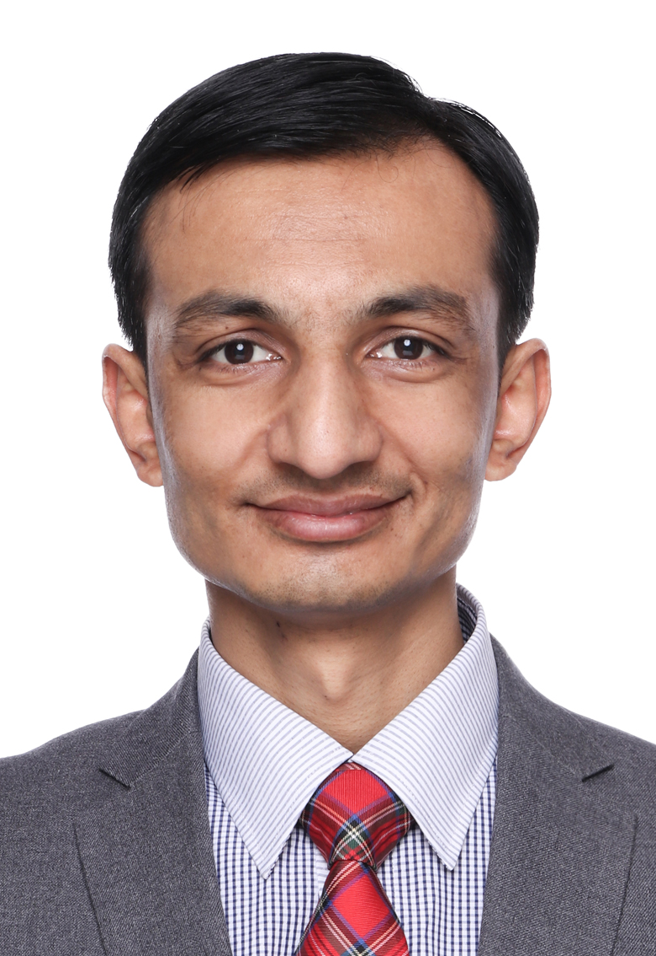
DR. NAJABAT ALI

Email: alinajabat@hotmail.com

Cell phone / Whatsapp / Line: 0092-3155726449

Address: House # 10, Street # 4, Subhan Royal Homes, Royal Avenue, Lane # 10, Park Road, Chak Shehzad, Islamabad, Near Comsat University, Pakistan, 44000.

Education

Post Doctorate Finance and Economics Sep.2019- Sep.2021
Jiangsu University, China
Doctor of Philosophy (PhD.) Finance, International Trade and Economics Sep. 2015-Jul. 2019
Shanghai University, China
Master of Philosophy (M.Phil) Economics Mar. 11-Mar. 2015
Hamdard University, Karachi, Pakistan
Masters of Business Administration (MBA) Finance Jan. 2007- Dec. 2009
Newports Institute of Communications and Economics, Karachi, Pakistan
Bachelors of Commerce (B.COM) Commerce Jan. 2005-Dec. 2006
University of Karachi, Pakistan
ICS Computer Science Sep. 2002-Aug. 2004
Bahria Foundation College, Karachi Pakistan
SSC Science Jun. 2000-Jun. 2002
Fauji Foundation Model School, Gilgit Pakistan

PhD. Dissertation
Impact of Investment and Trade on the Economic Growth of Pakistan

Research Publications
1. Paper Title: Impact of economic openness and innovations on the environment of ASEAN countries
Journal: Polish Journal of Environmental Studies
Status: Accepted

2. Paper Title: Environmental Impacts of Coronavirus: A review
Journal: Polish Journal of Environmental Studies
Status: Accepted

3. Paper Title: The dependency of rural livelihood on forest resources in Northern Pakistan’s Chaprote Valley
Journal: Global Ecology and Conservation
Status: Published
Ali, N., Hu, X., & Hussain, J. (2020). The dependency of rural livelihood on forest resources in Northern Pakistan's Chaprote Valley. Global Ecology and Conservation, e01001.

4. Paper Title: Sufficient funds act as a life blood for a business: “an opinion from real estate business in Karachi, Pakistan
Journal: International Journal of Management
Status: Published

5. Paper Title: Modern Technology Improves the Business Performance: A Survey of Hotel Business in Karachi, Pakistan.
Journal: International Journal of Management
Status: Accepted

6. Paper Title: Modern marketing techniques act as a catalyst for the selling activities of an entrepreneur: “An investigation of bakery and confectionery business in District Malir, Karachi, Pakistan”.
Journal: International Journal of Management
Status: Published

7. Paper Title: Measuring innovation capability of high-tech industries of China
Journal: Technovation
Status: Under-Review

8. Paper Title: How FDI promotes green technological innovation in BRI countries
Journal: European Economic Review
Status: Under-Review

9. Paper Title: Dynamics between green innovation and environmental quality: new insights into South Asian economies
Journal: economia politica
Status: Under-Review

10. Paper Title: An empirical on innovation, research and development expenditure, and agricultural GHG emissions: Empirical evidence from the panel system GMM approach
Journal: Climate Change Economics
Status: Under-Review

11. Paper Title: Renewable Energy Investment and governance in countries along the Belt and Road Initiative: Does trade openness matter?
Journal: Environmental Science and Pollution Research
Status: Under-Review

12. Paper Title: An analysis of farm technical efficiency, and role of training and technology using Simar Wilson 2007
Journal: Agribusiness
Status: Under-Review

13. Paper Title: Terrorism impedes innovation activity: Cross country empirical evidence (Under Review)
Journal: Defense and Peace Economics
Status: Under-Review

14. Paper Title: Impact of FDI on technological innovation of BRICS countries
Journal: Journal of Asia Pacific Economy
Status: Under-Review

15. Paper Title: The Role of FDI in the Economy of Pakistan for the period of 1971-2018
Journal: European Online Journal of Natural and Social Sciences
Status: Published
Ali, N., & Shaheen, R. (2019). The role of FDI in Economy of Pakistan for the period of 1971-2018’. European Online Journal of Natural and Social Sciences, 8(1), 10-17.

16. Paper Title: Title: Impact of Foreign Direct Investment on the Economic Growth of Pakistan
Journal: American Journal of Economics
Status: Published
Ali, N., & Hussain, H. (2017). Foreign Direct Investment, Impact of Foreign Direct Investment on the Economic Growth of Pakistan’. American Journal of Economics, 7(4), 163-170.

17. Paper Title: Foreign Direct Investment, International Trade and Economic Growth in the Economic Perspective of Pakistan
Journal: American Journal of Economics
Status: Published
Ali, N., & Xialing, L. (2017). Foreign Direct Investment, International Trade and Economic Growth in Pakistan’s Economic Perspective’. American Journal of Economics, 7(5), 211-215.

18. Paper Title: The Role of Cement Industry in the Economic Development of Pakistan
Journal: International Journal of Multidisciplinary Research Academy
Status: Published
Ali, N. (2015). The Role of Cement Industry in the Economic Development of Pakistan. Interdisciplinary Journal of Contemporary Research in Business, 5(3). 75-86

19. Paper Title: Private Sector Investment Opportunities in Health Sector: A case study of Gilgit Baltistan
Journal: International Journal of Multidisciplinary Research Academy
Status: Published
Anwer, M., Ali, N., Jaffar, A., & Ali, D. (2015). Private sector investment opportunities in health sector, the case study of Gilgit Baltistan. 5(3), 87-112

20. Paper Tile:
Impact of Flood on Sugarcane Industry of Pakistan
Journal: International Journal of Contemporary Journal in Business
Status: Published
Raza, M., Saeed, A., Shahid, S., & Ali, N. (2013). Impact of Flood on Sugarcane Industry of Pakistan. Interdisciplinary Journal of Contemporary Research in Business, 4(11), 92-105

21. Paper Title: The Impact of Cement Manufacturing on Economic Development of Pakistan: The Analysis of Cement Industry
Journal: International Journal of Research
Status: Published
Ali, N., Jaffar, A., Anwer, M., Anjum, M., Raja, M., Haider, M., & Xu, M. (2015). The Impact of Cement Manufacturing on Economic Development of Pakistan: The Analysis of Cement Industry. International Journal of Research (IJR), 2(2), 205-220

22. Paper Tile: An Innovative Approach in Decision-making Environments: Assessing Performance by Applying Multi-Attribute Value Theory (MAVT)
Journal: Asian Journal of Multidisciplinary Studies
Status: Published
Jaffar, A., Ming, X., Raja, M., Tetteh, A., Hussain, A., Anwer, M., & Ali, N. (2015). An Innovative Approach in Decision-Making Environments: Assessing Performance by Applying Multi-Attribute Value Theory (MAVT). Asian Journal of Multidisciplinary Studies, 3(2), 141-150

23. Paper Tile: The Greenhouse Gas Emissions Produced by Cement Production and its Impact on Environment: A Review of Global Cement Processing
Journal: International Journal of Research
Status: Published
Ali, N., Jaffar, A., Anwer, M., Khan, S., Anjum, M., Hussain, A., & Ming, X. (2015). The greenhouse gas emissions produced by cement production and its impact on environment: A review of global cement Processing. International Journal of Research (IJR), 2(2), 488-500

24. Paper Tile: Economic Analysis of Tobacco Industry: A Case Study of Tobacco Industry of Pakistan
Journal: International Journal of Research
Status: Published
Ali, N., Jaffar, A., Anwer, M., Raza, M., & Ali, N. (2015). The Economic Analysis of Tobacco Industry: A Case Study of Tobacco Production in Pakistan. International Journal of Research (IJR), 2(3), 88-99

25. Paper Tile: Screening of Children with Special Needs in Regular Primary Schools of District Gilgit, Gilgit Baltistan, Pakistan
Journal: International Journal of Research
Status: Published
Anwer, M., Jaffar, A., Ali, N., & Ali, D. (2015). Screening of Children with Special Needs in Regular Primary Schools of District Gilgit, Gilgit-Baltistan, Pakistan. International Journal of Research (IJR), 2(2), 29-47

26. Paper Tile: Comparative Assessment of the Analytical Risk-Averse Premium Model and its Risk and Returns: Critical Analysis of Capital Asset Pricing Model (CAMP)
Journal: Journal for Studies in Management and Planning
Status: Published
Shah, H., Jaffar, A., Anwer, M., & Ali, N. (2015). Comparative Assessment of the Analytical Risk-averse Premium Model and its Risk and Returns: Critical Analysis of Capital Asset Pricing Model (CAMP). Journal for Studies in Management and Planning, 1(2), 293-304

27. Paper Tile: Analyzing Job Satisfaction of the Employees of National Commission for Human Development (NCHD) in Pakistan.
Journal: Asian Journal of Multidisciplinary Studies
Status: Published
Anwer, M., Jaffar, A., Ali, N., Ali, D., & Ali, N. (2015). Analyzing Job Satisfaction of the Employees of National Commission for Human Development (NCHD) in Pakistan. International Journal of Research (IJR), 2(2), 894-920

27. Paper Tile: Investigating Special Needs of Children in Skardu District, Union Council Gamba: An Analysis of Establishing Special Education Complex in Baltistan Division of Pakistan
Journal: Asian Journal of Multidisciplinary Studies
Status: Published
Anwer, M., Jaffar, A., Ali, N., Khan, S., Ali, N., Raja, M., & Hussain, A. (2015). Investigating Special Needs Children in Skardu District, Union Council Gumba: An Analysis of Establishing Special Education Complex in Baltistan Division of Pakistan. Asian Journal of Multidisciplinary Studies, 3(3), 132-141

28. Paper Tile: The Cement Industry of Pakistan: A SWOT Analysis
Journal: Journal for Studies in Management and Planning
Status: Published
Ali, N., Anwer, M., Jaffar, A., & Raza, M. (2015). The cement industry of Pakistan: A swot analysis. Journal for Studies in Management and Planning, 1(2), 236-245

29. Paper Tile: Impact of Peer Tutoring on Learning of Students
Journal: Journal for Studies in Management and Planning
Status: Published
Ali, N., Anwer, M., & Jaffar, A. (2015). Impact of peer tutoring on learning of students. Journal for Studies in Management and Planning, 1(2), 61-66

30. Paper Tile: Nurturing Sustainable Teachers’ Leadership Culture: Possibilities, Challenges, Stakeholders’ Behavior Analysis in the Context of Pakistan
Journal: Journal for Studies in Management and Planning
Status: Published
Shah, S. S., Ali, N., Anwer, M., & Jaffar, A. (2015). Nurturing Sustainable Teachers’ Leadership Culture: Possibilities, Challenges, Stakeholders’ Behavior Analysis in the Context of Pakistan. International Journal of Research (IJR), 2(3). 593-600

31. Paper Tile: The Effects of Work Pleasure on Faculty Members Job Satisfaction in Ideal Environment: A Case Study of Gomal University, Dera Ismail Khan, Pakistan
Journal: Journal for Studies in Management and Planning
Status: Published
Jaffar, A., Ming, X., Anwer, M., Ali, F. A., & Ali, N. (2015). The effects of work pleasure on faculty members job satisfaction in ideal environment: A case study of Gomal University, Dera Ismail Khan, Pakistan. Journal for Studies in Management and Planning, 1(2). 278-292

32. Paper Tile: Declining Employee Performance in Public Sector Organizations: An Etiological Study of Public Sector Organizations in Pakistan
Journal: Journal for Studies in Management and Planning
Status: Published
Shah, S. K. A., & Ali, N. A. Z. (2015). Declining Employee Performance in Public Sector Organizations: An Etiological Study of Public Sector Organizations in Pakistan. Journal for Studies in Management and Planning, 1(5). 55-64

33. Paper Tile: Developing Effective Teachers’ Evaluation System: A Study of Educational Institutions in Karachi
Journal: Journal for Studies in Management and Planning
Status: Published
Shah, K., Ali, Z., & Ali, N. (2015). Developing effective teachers’ evaluation system: A study of educational institutions in Karachi. Journal for Studies in Management and Planning, 1(5), 64-75
Books
Title: The Role of Cement Industry in the Economic Development of Pakistan
LAP LAMBERT Academic Publishing, Germany
Status: Published

Awards
Best Article Award in the competition arranged by College of International Exchange, Shanghai University
Language Proficiency
Read Write Speak
- English Advanced Advanced Fluent
- Urdu Advanced Advanced Fluent
- Chinese Basic Basic Basic

Job Experience
February 2021- Till Date, Assistant Professor, Hamdard Institute of Management Sciences (HIMS), Hamdard University, Islamabad Campus.

September 2019– Sep.2021, Post-Doctoral Candidate, School of Finance and Economics, Jiangsu University, Zhenjiang, China.

January 2018- July 2019, Professor of Economics, CUSSA International, Shanghai Campus, China.

August 2016-December 2017, Visiting Lecturer, School of Economics and Finance, Shanghai University, Shanghai, China.

February 2012– June 2015, Lecturer of Economics and Management, Newports Institute of Communications and Economics, Karachi, Pakistan

January 2012 – December 2012, Lecturer, The Learning House College, Karachi, Pakistan

April 2012 – December 2014, Visiting Lecturer of Economics and Management, Dadabhoy Institute of Higher Education, Karachi, Pakistan

January 2010 – December 2011, Administrator and English Language Teacher, APHR
Evening Institute, Karachi, Pakistan

May 2007 – December 2010, Teacher and Coordinator, Beacon House School System, Karachi, Pakistan

References Will be provided, if required.

