**BIODATA**

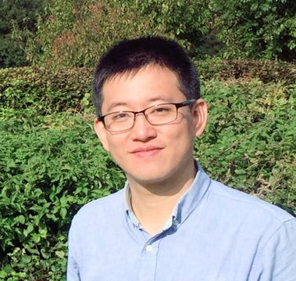Dr Fan Fang obtained his PhD from the Centre for Global Englishes, University of Southampton, UK and an MA from the University of Leeds, the UK. He is currently Associate Professor at College of Liberal Arts, Shantou University, China. His research interests include Global Englishes, applied linguistics, sociolinguistics, language attitude, identity, intercultural communication, teacher education and language teaching and learning.

Dr Fan Fang has published articles in journals including *Asia Pacific Journal of Education*, *Asian Englishes*, *ELT Journal*, *English Today*, *Journal of Multilingual and Multicultural Development*, *Language, Culture and Curriculum*, *Language Teaching Research*, *Lingua*, *RELC Journal*, *System*, among others. His latest books include a monograph titled *Re-positioning accent attitude in the Global Englishes paradigm: A critical phenomenological case study in the Chinese context* (Routledge) and an edited volume (co-edited with Dr Handoyo Widodo) titled *Critical Perspectives on Global Englishes in Asia: Language Policy, Curriculum, Pedagogy and Assessment* (Multilingual Matters).

**Email**: [ffang@stu.edu.cn](mailto:ffang@stu.edu.cn)