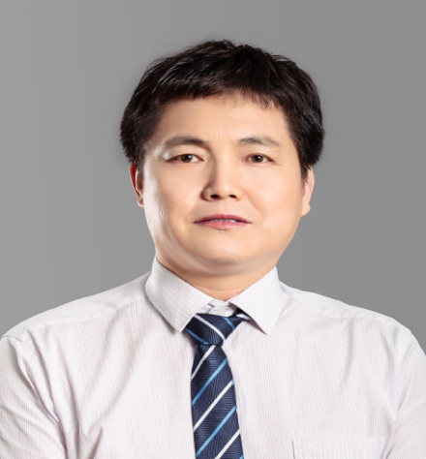
亢 升 教授
Prof. Kang Sheng
School of Marxism, South China University of Technology
E-mail: shkang@scut.edu.cn

Position: Professor
Expertise
- The Diplomacy with Chinese characteristics and International Relations
- Sinicization of Marxism
Work experiences
- Researcher of Academic Research office, Department of political science and administrative management, School of Shaanxi provincial Party committee
- Lecturer of School of Political Ideology, South China University of Technology
- Lecturer of School of Marxism, South China University of Technology

