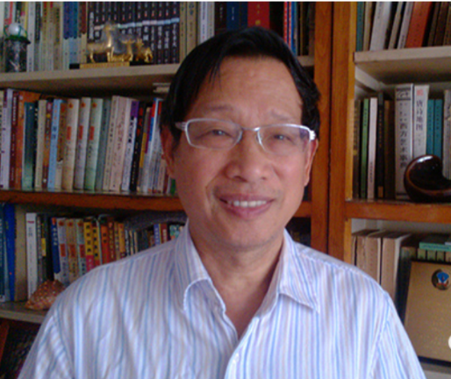
谭元亨 教授
Prof. Tan Yuanheng,
School of Journalism & Communication, South China University of Technology
(Visiting Professor of School of Marxism, South China University of Technology)
E-mail: 2892946522@qq.com, yuanhengtan@163.com

Position: Professor
Work experiences
- Director of Hakka Research Institute
- Member of China Writers Association
- Member of China Television Artists Association
- Member of International IR SCL and professional writer of Hunan Writers Association
- Member of Hunan CPPCC
- Counselor of Guangdong provincial government
- Vice president of China new literature society

Honors and Academic works
- Won 5 national government awards
- Won 5 national awards
- More than 200 literary, historical and philosophical works have been published

