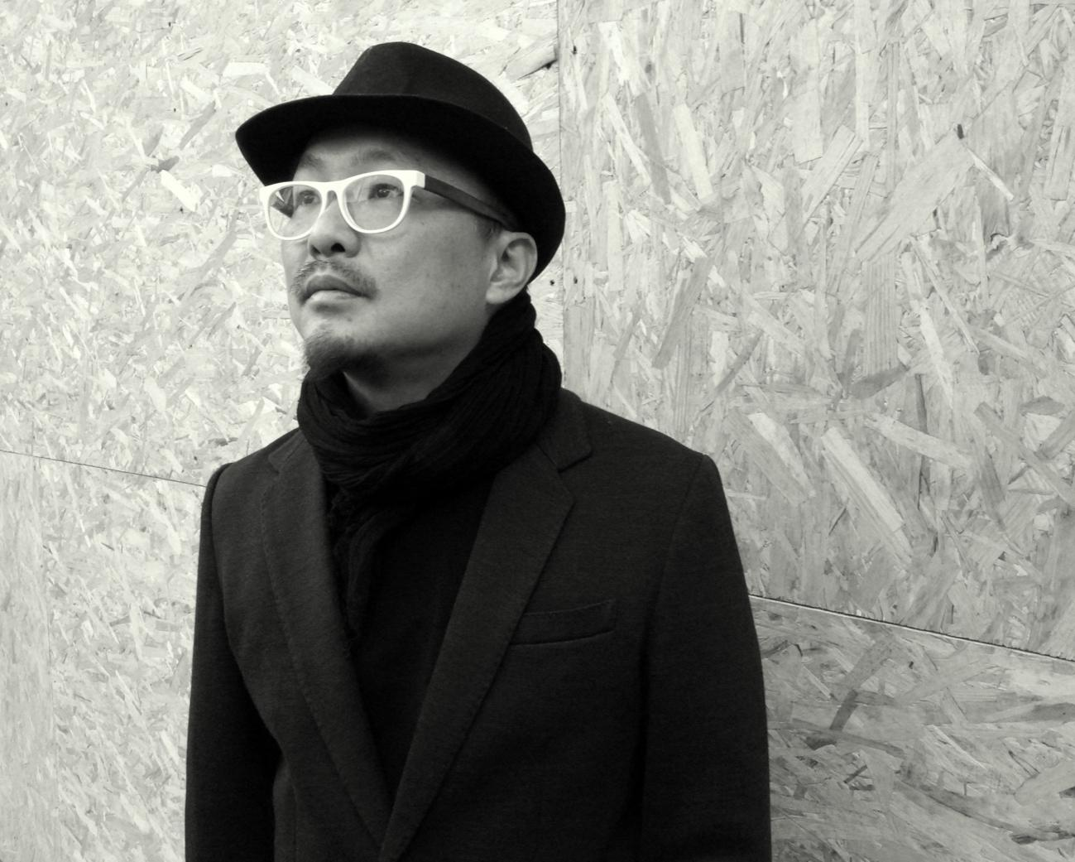

**PROF. DR. TING, CHAWCHEN**

Degrees: MArch (UT Austin) D. Lit. (Tsinghua University)

Job Title: Professor of Art & Design, Beijing Institute of Fashion Technology, China

Date of birth: 5 December, 1967

Mobile: +86-13488728722

E-Mail: ding@bift.edu.cn

Citizenship: Republic of China (Taiwan)

**BIOGRAPHY**

Dr. Professor Ting, Chawchen, born in Taiwan in 1967, has many years of interdisciplinary industrial and academic experiences. In 1997, he obtained a master's degree in Architectural Design from the University of Texas at Austin; from 1997 to 2000, he worked in the Internet industry and had co-founded the streaming map website Telemap.com.tw, and served as the design director of 104 Job Bank, Taiwan’s largest Internet recruitment company; from 1999 to 2001, he served as a senior project manager in the international consulting company Ionglobal, serving global top 500 technology industry customers; in 2002, he entered Taipei Shi Chien University as a full-time lecturer and worked until 2003 before he started PhD study in Beijing; in 2006, he received PhD in Art and Design from Tsinghua University; from 2007 to now, he has served Beijing Institute of Fashion Technology over 14 years.

Since 2014, he has become the Director of the New Media Department, managing 50 teachers in two disciplines: Digital Media Art and Animation. Since 2013, he has published various popular design textbooks like *Introduction to Service Design: Twelve Lessons of Innovation Practice*, *Lighting up 100 International Innovation Cases of Health Design*, *Lighting up Senior Design 100 International Innovation Cases*, *Digital Game Design & Planning*, *The History of Digital Entertainment Design* etc. In 2020, he assisted the Digital Media Art discipline to successfully obtained the National Excellence Discipline Development Point, and stood out among many schools in the country. In the 2021 Academic Ranking of China Universities, the discipline of Digital Media Arts of Beijing Institute of Fashion Technology ranks second in the nation, under the top ten with the Communication University of China and Tsinghua University.

While being serving as departmental director, he had also dealt withe school’s international affairs, he had assisted the school in promoting international exchanges. From 2014 to 2017, he was the director of the International Office of the School of Art and Design, and had promoted more than 30 international exchanges of faculties and students every year, and had helped signing more than twenty university level MOUs.

In addition to his full-time academic job, he also actively involves with the many industrial activities, and has following part-time jobs: Member of the Expert Committee of Chinese Service Design Talent and Institutional Evaluation (2021-current); Chairman of the International Council of the Italian Cultural and Fashion Center (2021-current); Member of the Mobile Media and Cultural Computing Committee of China Institute of Communications (2019-current); Visiting Professor of the Virtual Reality Research Institute of Guangzhou Greater Bay Area (2019-2021); Director of The Designers: Cross-Strait Design Talent Development Program of Beijing International Design Week (2014); Member of the Academic Committee of Beijing Key Laboratory of Digital and Interactive Media (2011-2014); Distinguished Professor of Shanghai Theater Academy (2011-2013); Researcher of the Games & Experimental Entertainment Laboratory of RMIT University (2011-2014); Researcher of Cultural and Creative Industry Center of National Taiwan Normal University (2009-2012); Director of Beijing Digital Entertainment Jam(2007-2009).

Currently, Professor Ting’s research focuses involved two parts: Health Design and Senior Experience Design. In Health Design, he has started the Urban Sleep Sanctuary project in 2014, which is the first domestic research/design task force comprehensively involve "sleep designs", covering projects including branding, food design, entertainment design, space design, information visualization, product design, etc. He has cooperated with Taipei Medical University, Taiwan Corning Hospital, International Sleep Science and Technology Association, the China Smart Furniture Industrial Alliance, and JD Smart etc.; In Senior Experience Design, he had involved with resolving Digital Literacy issues by cooperating with the country's internet giant Tencent in a large-scale workshop named Design Day Marathon and The Tengyun Summit in the year 2018. In 2020, he cooperated with the Memory Center of the Peking University Sixth Hospital and designed cognitive training products for the elderly. That was a toolkit called Once More Cognitive Training Package for the Elderly through the nostalgic therapy for dementia.

**RESEARCH FOCUSES**

**Wellness Technology & Design**

**Digital Lifestyle Design**

**Digital Entertainment Design**

**HIGHER EDUCATION**

**2003/09 - 2006/12**

Degree: Doctor of Literature

Major: Art & Design

School: Department of Information Art Design, Academy of Fine Arts, Tsinghua University (China)

Supervisor: Professor Lu Xiaobo, Dean of Academy of Fine Arts, Tsinghua University

Dissertation: “Cognition and Experience — Research on the Design Mode of Video Game Space"

Introduction: Introduction: During the period, I published the first Chinese doctoral dissertation on ludic architecture, Cognition and Experience - Research on the Design Pattern of Video Game Space, which opened up further research explorations and design practices in Chinese game designs.

**1994/09 - 1997/05**

Degree: Master of Architecture

Major: Architecture Design

School: University of Texas at Austin (USA)

Supervisor: Charles Moore

Introduction: The University of Texas at Austin (UT) is ranked 7th public university in the States. In my second year of graduate school, I won the scholarship of "Lugano Program" and went to six European countries with my supervisors and 20 students to complete the master's degree in the intensive and systematic transnational architecture travel study.

**1990/09 - 1994/05**

Degree: Bachelor of Science

Major: Architectural Engineering

School: University of Texas at Arlington(USA)

**QUALIFICATION**

**2010/07**

Name: Postdoctoral Researcher

Major: Philosophy

Unit: Cultural Industry Research Center, Chinese Academy of Social Sciences (China)

Supervisor: Zhang Xiaoming, Director of Cultural Industry Research Center

Achievement: " Global Digital Entertainment Development Trends Report "

Introduction: In 2008, I conducted a post-doctoral research at the Cultural Industry Research Center of the Institute of Philosophy, Chinese Academy of Social Sciences and Chinese Academy of Social Sciences. The instructor was Professor Zhang Xiaoming. The research direction was digital content industry strategy and macro development trends. During this period, I assisted UNCTAD and Chinese Academy of Social Sciences held two China International Cultural Industry Forums and submitted an outbound report in 2010: "Digital Cultural Industry Research-Digital Entertainment Design", and finally obtained a post-doctoral certificate.

**1997/09**

Name: Microsoft Certified Systems Engineer (MCSE)

Major: Systems Engineering

Unit: Microsoft Headquarters

Supervisor: na

Achievement: qualification certificate

Introduction: I passed the qualification certificate of Microsoft Certified System Engineer in 1997. MCSE is one of the high-end certifications in Microsoft certification. It represents certified professionals who have considerable experience and knowledge in the construction, management, deployment and maintenance of Microsoft's server, network technology, system management, etc. It is suitable for network engineers , system administrator, system engineer or network manager and other positions.

**1997/05**

Name: Microsoft Certified Professional + Internet

Major: Internet Technology

Unit: Microsoft Headquarters

Supervisor: na

Achievement: qualification certificate

Introduction: I passed the Microsoft Certified Internet Expert Qualification Certificate in 1997. MCP is the earliest and longest-used certification title among Microsoft certifications. It is currently only a Microsoft Certified Professional Program. On behalf of certified professionals, they have considerable experience and knowledge in specific fields such as Microsoft systems, Internet or network technology.

**WORK EXPERIENCES**

**2007 - current**

Position: Professor, Phd. Supervisor, Director of New Media and Animation

Organization: Beijing Institute of Fashion Technology

Introduction: I have been teaching under the discipline of Digital Media Art and have taught courses like Information Design, New Media Design, Fashion Media Trends, Digital Lifestyle Research, Future Design and Intelligent Life, History of Digital Entertainment Design. My research focuses are Wellness Technology & Design, Digital Lifestyle Design, Digital Entertainment Design.

**2019 - current**

Position: Member of the 10th Academic Committee of Beijing Institute of Fashion Technology

Unit: Beijing Institute of Fashion Technology

Introduction: As a member of the academic committee of the university, I am mainly responsible for reviewing the vision plan and draft plan of scientific research of Beijing Institute of Fashion Technology, proposing suggestions for large-scale academic activities, reviewing reports on major research topics, and promoting academic exchanges and scientific cooperation between domestic and foreign universities.

**2019 - current**

Position: Doctoral supervisor of Beijing Institute of Fashion Technology

Unit: Graduate School of Beijing Institute of Fashion Technology

Introduction: I serve as a doctoral supervisor for a special program called Chinese Traditional Costume Culture Rescue and Inheritance Design Innovation, which emphasizes "digital science and technology innovation" on the basis of theoretical research, aiming to train students to find the link between science and inheritance in the future development of Chinese traditional costume.

**2011 - 2013**

Position: Distinguish Visiting Professor

Organization: Shanghai Theater Academy, China

Introduction: Assisted the Shanghai Theater Academy's School of Creativity to build up the curriculum of Digital Media Art; established cooperation with Busan Design Center in Korea and Politecnico di Milano in Italy; helped the director of Shanghai Key Laboratory of Virtual Performing Arts of Shanghai Theater Academy to carry out projects, international forums and exhibitions.

**2001 - 2003** Lecturer, Communication Design Dept., Shih Chien University, Taiwan

**1999 - 2001** Senior Associate, Ionglobal, Taiwan

**1998 - 2000** Co-founder, telemap.com.tw, Taiwan

**1997 - 1999** Executive Design Director, 104.com Job Bank, Taiwan

**PART-TIME PROFESSIONAL WORK**

**2021/06 - current**

Position: Member of China Service Design Talent and Organization Evaluation Expert Committee

Organization: Beijing Guanghua Design and Development Foundation

**2020/01 - current**

Position: Director of International Council of Italian Culture and Fashion Center

Organization: Italian Culture and Fashion Center

**2019/12 - current**

Position: Member of the Mobile Media and Cultural Computing Committee of China Institute of Communications

Organization: China Institute of Communications

**2019/11 - current**

Position: International expert of Yantai Industrial Design Center, University of Science and Technology Beijing

Organization: University of Science and Technology Beijing

**2019/09 - current**

Position: Member of Jingcai Taiwan New Media Expert Committee

Organization: Taiwan Affairs Office of the People's Government of Beijing Municipality

**2019/07 - current**

Position: Visiting Professor of the Virtual Reality Research Institute of Guangzhou Greater Bay Area

Organization: Guangzhou Greater Bay Area Virtual Reality Institute

**2018/07 - current**

Position: Member of Network Technology and Intelligent Media Design Committee

Organization: National Institute of Computer Basic Education Research Association

**SELECT PUBLICATIONS**

**2021/09**

Ting, Chawchen, Wu Lixing, Yang Yifan. Lighting up 100 Innovative Cases of Health Design[M]. 1st edition. Chengdu: Southwest Jiaotong University Press, 2021.

**2021/09**

Yang Yifan, Ting, Chawchen, Wu Lixing. Lighting up 100 Innovative Cases of Senior Design[M]. 1st edition. Chengdu: Southwest Jiaotong University Press, 2021.

**2018/09**

Li Sida, Ting, Chawchen. Introduction to Service Design: Twelve Lessons of Innovation Practice [M/OL]. Beijing: Tsinghua University Press, 2018.

**2011/06**

Ting, Chawchen. The history of digital entertainment design[M]. Beijing: Tsinghua University Press, 2011.

**2008/06**

Huang Shi, Ting, Chawchen, Chen Yanjie. Digital Game Planning[M]. Beijing: Tsinghua University Press, 2008.

**SELECT PAPERS**

**2020/08**

ZHAOCHEN D, ZHI L.Research on Product Design of Speech Interaction in the Therapy of Dementia[C/OL]. online: Chinese CHI, 2020.https://dl.acm.org/doi/10.1145/3403676.3403681.

**2020/06**

ZHAOCHEN D, ZHI L. Design Trend of Voice Interaction Technology Applied in China’s Elderly Home Care[C/OL]. online: HCI Korea, 2020: 433–438. https://www.dbpia.co.kr/Journal/articleDetail?nodeId=NODE10402776.

**2017/06**

DING Z. Alternative 3D Education for Children: Course Design of 3D Printing Interactivity for Beijing’s Primary Schools.[C]. Guangdong: Guangdong University of Technology, 20170608: 30–35. DOI:https://doi.org/10.1145/3080631.3080637.

**2015/06**

ZHAOCHEN D, MARGHERITA P, RONGLIN J. Mind your deep breath.Communicating pollution issues in China through visual artifacts[C/OL]. Milan: Cumulus, 2015: 17–27. https://re.public.polimi.it/handle/11311/972728#.XeXkqDIzY18.

**SELECT RESEARCH PROJECTS**

**2021 - 2022**

Title: Chinese Traditional Costume Art Digital Talent Training Project

Project: National Art Fund Art Talent Training Funding Project

Responsibility: second person in charge

Organization: National Arts Fund Management Center

Website: http://www.cnaf.cn

Introduction: This project is funded by the National Art Fund to promote the digital achievements of traditional costume art to the society, realize the industrial transformation of teaching achievements and train advanced digital technology to fashion talents. As one of the project leaders, I have designed the course curriculum for the Training Project that helps participants to understand the use of digital methods to preserve Chinese traditional costumes.

**2014 - 2017**

Title: Research and Practice of Integration and Innovation of International Design Talents

Project: School-level Educational Reform Project of Beijing Institute of Fashion Technology

Responsibility: first person in charge

Organization: Beijing Institute of Fashion Technology

Website: https://www.bift.edu.cn/

Introduction: This project is to assist Beijing Institute of Fashion Technology to establish an International Design Talent Integration Center to promote the cooperation and integration among international scholars, industry experts and designers.

**2014 - 2014**

Title: The Designers: Cross-Strait Design Talent Development Program

Project: Beijing International Design Week Design Talent Project

Responsibility: Director of Operations

Organization: 2014 Beijing International Design Week

Website: http://fashion.sina.com.cn/l/sn/2014-09-24/1729/doc-iavxeafr3879276.shtml

Introduction: The Designers is a design talent project of Beijing International Design Week, which is an O2O talent service platform built around the core resources of design industry. Based on talent selection, training and exchanging system, the platform has organized events through design award counseling, design competitions, designers' salons, talent exchange and promotion activities etc. As the operational leader, I have helped the project initiated its public website and the conference during the 2014 Beijing International Design Week.

**SELECT AWARDS, HONORS**

**2021/06**

Name: 2021 Academic Ranking of China Universities

Level: National Second Place in Digital Media Art Major

Responsibilities: departmental director

Organization: Shanghai Ranking Education Information Consulting Co., Ltd.

Website: https://www.shanghairanking.cn/rankings/bcmr/2021/130508

Introduction: Beijing Institute of Fashion Technology ranks second in the country in the Digital Media Art decipline, and ranks in the top ten with Communication University of China and Tsinghua University. 2021 Academic Ranking of China Universities covers more than 500 undergraduate deciplines. It is by far the largest Chinese university undergraduate professional ranking and one of the four authoritative university rankings in the world.

**2020/01**

Name: National Excellence Discipline Development Point

Level: Double Ten Thousand Award of The Ministry of Education

Responsibilities: departmental director

Organization: Ministry of Education

Website: https://www.bift.edu.cn/xwgg/bfxw/83702.htm

Introduction: I assisted the Digital Media Art discipline to successfully obtained the National Excellence Discipline Development Point, and stood out among many schools in the country. In 2019, the Ministry of Education launched the Double Ten Thousand Award for the construction of first-class undergraduate disciplines in order to comprehensively revitalize undergraduate education and improve the talent training capabilities.

**2015/07**

Name: Deep Breathing

Level: China's Green Technology Innovation Achievement

Responsibilities: project leader

Organization: Global Compact China Network Climate China Summit

Website: None

Introduction: On behalf of the Deep Breath team of Beijing Institute of Fashion Technology, I received the China's Green Technology Innovation Achievement during the event of Global Compact China Network Climate China Summit in July 2015. This Summit was supervised by Rae Kwon Chung, Chief Advisor to the Secretary-General of the United Nations on Climate Changes.

**2014/06**

Name: BIFT Scholar: Research and Practice of Integration and Innovation of International Design Talents

Level: Beijing Institute of Fashion Technology Scholar Fund

Responsibilities: receiver

Organization: Beijing Institute of Fashion Technology

Website: None

Introduction: I have been granted a three-year research fund as BIFT Scholar. During this period of time, I assisted the school to establish an International Design Talent Integration Center to promote the communications and cooperations of international faculties, industry professionals and designers.

**2013/07**

Name: The Politecnico di Milano International Fellowships

Level: Politecnico di Milano Global Scholar Fund

Responsibilities: receiver

Organization: Politecnico di Milano, Italy

Website: https://www.polimi.it/fileadmin/user_upload/Lavora-con-noi/internationl-fellowships/graduatoria_di_merito_PIF_2012.pdf

Introduction: The Politecnico di Milano began to recruit 11 researchers from around the world in 2012, covering the main cutting-edge disciplines of the school. I put forward a research plan on the research of Digital Media & Fashion, and won this global scholar fund in 2013, becoming the only Chinese who received this honor in the field of design.

**2007/05**

Name: Hong Kong, Macao and Taiwan Senior Talents Work Residence Permit

Level: Beijing Municipality

Responsibilities: receiver

Organization: Beijing Municipal Bureau of Human Resources

Website: None

Introduction: I obtained this Work Residence Permit when I joined Beijing Institute of Fashion Technology in 2007, becoming the first Taiwanese personnel to hold an important job in Beijing Institute of Fashion Technology. In 2002, the Beijing Municipal Bureau of Personnel issued the implementation opinions on personnel policies concerning the working permit of senior prefessionals from Hong Kong, Macau and Taiwan Regions.

**PATENTS**

**2018/07**

Name: A Sleeping Speaker (ZL201720406863.8)

Level: Utility Model Patent of the People's Republic of China

Responsibilities: first designer

Organization: Beijing Institute of Fashion Technology

Website: http://www.soopat.com/Patent/201720406863

Introduction: This patent is a speaker for sleeping aid, which includes: battery, speaker, housing; CPU processor module.

**2017/10**

Name: Mobile phone with interactive interface (201730138368.9)

Level: Appearance Patent of the People's Republic of China

Responsibilities: first designer

Organization: Beijing Institute of Fashion Technology

Website: http://www.soopat.com/Patent/201730138368

Introduction: This patent is an APP for behavior changing. The main point of this design is the graphical user interface used to help users develop a good sleep habits.

**2014/01**

Name: Toy Design (ZL201330346861.1)

Level: Utility Model Patent of the People's Republic of China

Responsibilities: first designer

Unit: Beijing Institute of Fashion Technology

Website: http://www.soopat.com/Patent/201330346861

Brief introduction: This patent is the appearance design of a toy (doll) product.