Professor Philip Marriott Biography
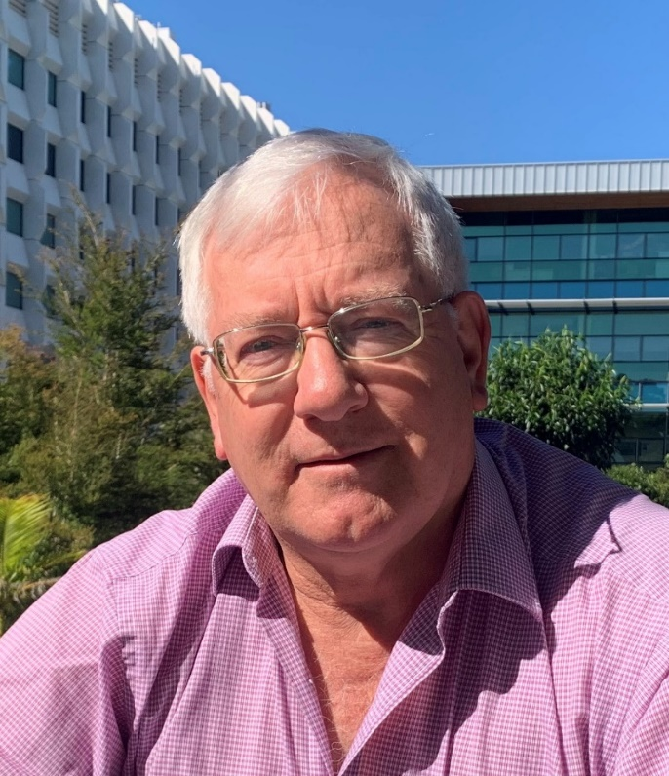

Name: Professor Philip J Marriott
Organisation: Monash University, School of Chemistry
Profile Web Link: http://www.monash.edu/science/schools/chemistry/our-people/staff/marriott
Short Biography:
Professor Marriott obtained his PhD from LaTrobe University, Melbourne. He undertook postdoctoral research at the University of Bristol, UK, in Organic Geochemistry.
His first academic appointment (5 years; Senior Lecturer) was at the National University of Singapore, Department of Chemistry.
He returned to Australia, and then in 2010, he moved to his present position as Professor at Monash University, Melbourne.
He received an Australian Research Council Discovery Outstanding Researcher Award in 2013.
He has had extended Australian Academy of Science professorial visits to China and Portugal, and has external Professor appointments to universities in Malaysia and Hong Kong. He was recipient of a World Class University Distinguished Professorship under the Korean National Research Foundation. In 2015, he received a CNPq Special Researcher Award, to work with the Federal University of Rio de Janeiro, and Embrapa, Brazil, for a project on coffee and natural oils from Brazil.
His primary research is in gas chromatography and mass spectrometry, specifically in comprehensive 2D GC and multidimensional GC, with mass spectrometry, covering fundamental method development and a broad applications base, including essential oils, petrochemicals, foods, pesticides, chemical weapons and toxins, and drugs.
In 2017 he received the Federation of Asian Chemical Societies, Foundation Lectureship Award, in Analytical Chemistry; in 2019 the COLACRO medal for contributions to Separation Science in South America; and in 2021 the Halász medal from the Hungarian Separation Science Society.
Professor Marriott has published about 400 research papers and 30 book chapters.

